[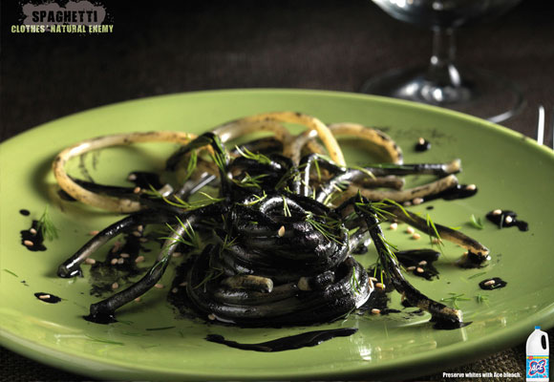](http://adsoftheworld.com/media/print/ace_tarantula?size=_original)[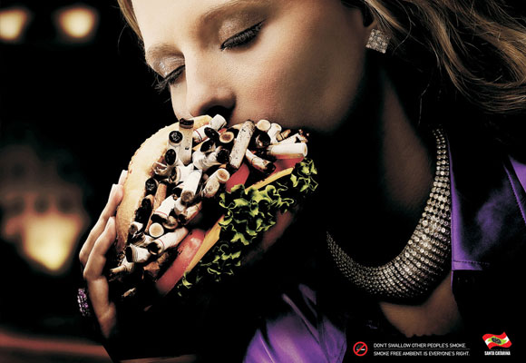](http://adsoftheworld.com/media/print/government_of_the_state_of_santa_catarina_hamburger?size=_original)[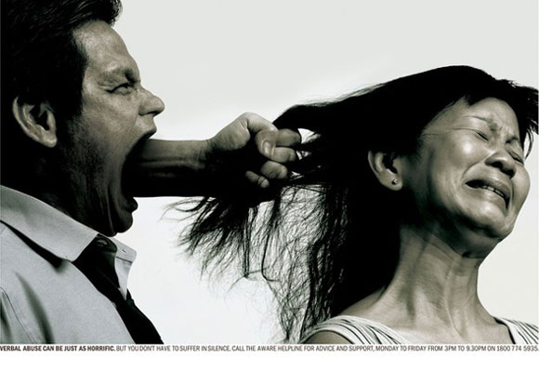](http://adsoftheworld.com/media/print/aware_helpline_verbal_abuse_1?size=_original)[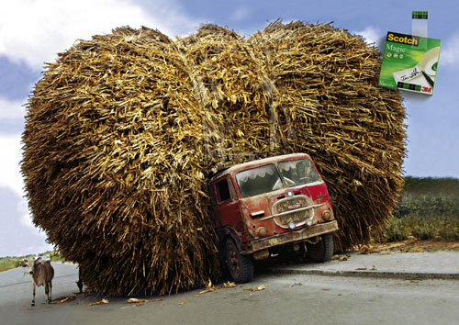](http://awesomeinspiration.net/post/30927944523)

[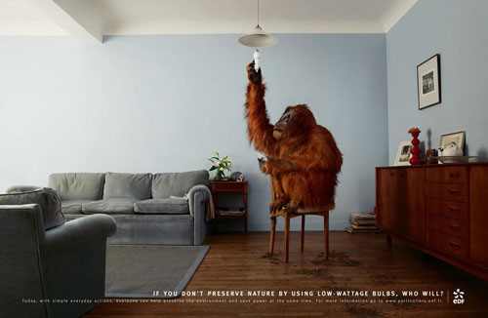](http://awesomeinspiration.net/post/30928165662)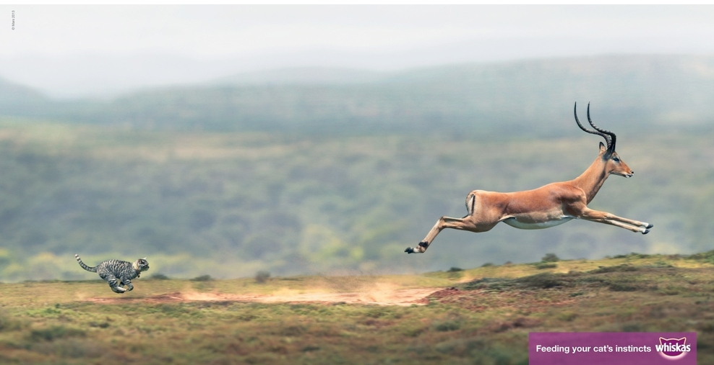[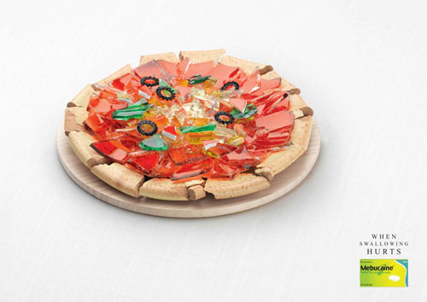](http://awesomeinspiration.net/post/30928135381)[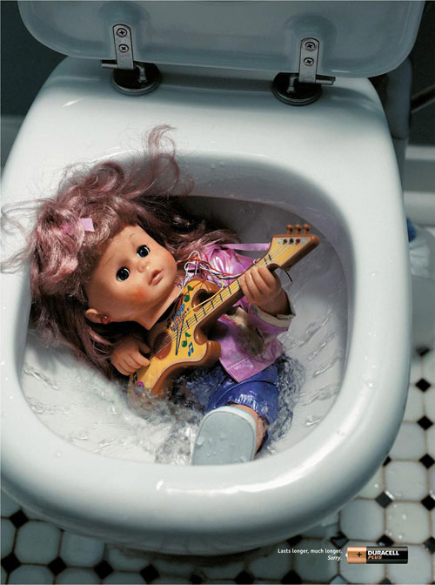](http://awesomeinspiration.net/post/30927982336)[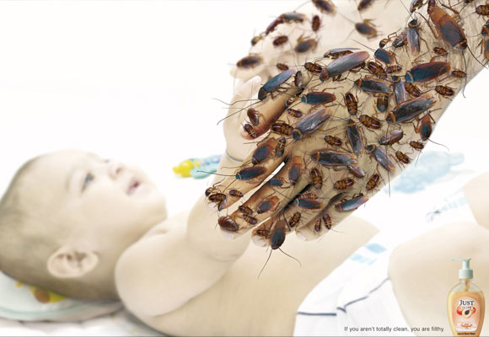](http://adsoftheworld.com/media/print/just_liquid_hand_wash_cockroaches?size=_original)

[](http://adsoftheworld.com/media/print/ace_tarantula?size=_original)[](http://adsoftheworld.com/media/print/government_of_the_state_of_santa_catarina_hamburger?size=_original)[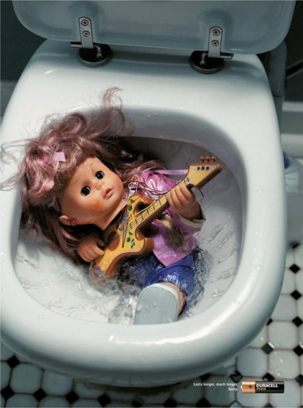](http://awesomeinspiration.net/post/30927982336)[](http://adsoftheworld.com/media/print/aware_helpline_verbal_abuse_1?size=_original)[](http://awesomeinspiration.net/post/30927944523)[](http://awesomeinspiration.net/post/30928165662)[](http://adsoftheworld.com/media/print/just_liquid_hand_wash_cockroaches?size=_original)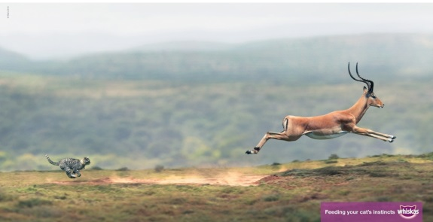[](http://awesomeinspiration.net/post/30928135381)